Software Quality Engineering
PBL

Submitted by:
Ahmad Zia
M. Abdullah
SAP ID: 54635 & 47618
BSSE 6

Project Title:
Intern Connect System (DSA)

TEST PLAN:

Project Information
Field | Details
Project Name | InternConnect – Internship Management System
Project Type | DSA Based Console Application
Programming Language | C++
Testing Type | Manual Testing
Testing Environment | Dev C++
Tester Name | Ahmad Zia , M.Abdullah

TEST SCENARIOS:
Scenario ID | Test Scenario | Module
TS-01 | Verify that the application launches successfully | Main System
TS-02 | Verify that the main menu displays correctly | Main System
TS-03 | Verify student signup with valid data | Student Module
TS-04 | Verify student signup with invalid CNIC | Student Module
TS-05 | Verify student signup with invalid phone number | Student Module
TS-06 | Verify student signup with invalid email format | Student Module
TS-07 | Verify duplicate CNIC validation | Student Module
TS-08 | Verify duplicate email validation | Student Module
TS-09 | Verify student login with correct CNIC | Student Module
TS-10 | Verify student login with incorrect CNIC | Student Module
TS-11 | Verify display of student status after login | Student Module
TS-12 | Verify company signup with valid data | Company Module
TS-13 | Verify company signup with duplicate email | Company Module
TS-14 | Verify company login with correct credentials | Company Module
TS-15 | Verify company login with incorrect credentials | Company Module
TS-16 | Verify viewing of pending student requests | Company Module
TS-17 | Verify accepting a student request | Company Module
TS-18 | Verify rejecting a student request | Company Module
TS-19 | Verify admin login with correct credentials | Admin Module
TS-20 | Verify admin login with incorrect credentials | Admin Module
TS-21 | Verify viewing student records | Admin Module
TS-22 | Verify viewing company records | Admin Module
TS-23 | Verify deleting a student record | Admin Module
TS-24 | Verify deleting a company record | Admin Module
TS-25 | Verify clearing all database records | Admin Module
TS-26 | Verify invalid menu option handling | Main System
TS-27 | Verify system stability with unexpected inputs | Main System
TS-28 | Verify overall usability and navigation of the system | Main System

- TEST CASES:

FIRST: STUDENT MODULE TEST CASES

TEST CASE 1 — Student Signup with Valid Data
Field | Details
Test Case ID | TC-01
Test Scenario | Verify student signup with valid data
Module | Student Module
Preconditions | Application is running
Steps | 1. Select Student Module 2. Click Signup 3. Enter valid details
Test Data | Name: Ali Khan  Expertise: Web Development  CNIC: 1234567890123  Phone: 923001234567  Email: ali@gmail.com
Expected Result | Student account should be created successfully
Actual Result | Student account created successfully
Status | Pass

TEST CASE 2 — Student Signup with Invalid CNIC
Field | Details
Test Case ID | TC-02
Test Scenario | Verify invalid CNIC validation
Module | Student Module
Preconditions | Application is running
Steps | 1. Open Student Signup 2. Enter invalid CNIC
Test Data | CNIC: 12345
Expected Result | System should display invalid CNIC error
Actual Result | Error message displayed correctly
Status | Pass

TEST CASE 3 — Student Signup with Invalid Phone Number
Field | Details
Test Case ID | TC-03
Test Scenario | Verify invalid phone number validation
Module | Student Module
Preconditions | Application is running
Steps | 1. Open Signup 2. Enter invalid phone number
Test Data | Phone: 03001234567
Expected Result | System should reject phone number
Actual Result | Invalid phone number error displayed
Status | Pass

TEST CASE 4 — Student Signup with Invalid Email
Field | Details
Test Case ID | TC-04
Test Scenario | Verify invalid email validation
Module | Student Module
Preconditions | Application is running
Steps | 1. Open Signup 2. Enter invalid email
Test Data | Email: azia23gmail.com
Expected Result | System should display invalid email error
Actual Result | Error displayed correctly
Status | Pass

TEST CASE 5 — Duplicate CNIC Validation
Field | Details
Test Case ID | TC-05
Test Scenario | Verify duplicate CNIC validation
Module | Student Module
Preconditions | Student already exists
Steps | 1. Signup again using same CNIC
Test Data | CNIC: 1234567890123
Expected Result | System should reject duplicate CNIC
Actual Result | Duplicate CNIC error displayed
Status | Pass

TEST CASE 6 — Student Login with Correct CNIC
Field | Details
Test Case ID | TC-06
Test Scenario | Verify student login with valid CNIC
Module | Student Module
Preconditions | Student account already exists
Steps | 1. Open Student Login 2. Enter CNIC
Test Data | CNIC: 1234567890123
Expected Result | Student should login successfully
Actual Result | Login successful
Status | Pass

TEST CASE 7 — Student Login with Wrong CNIC
Field | Details
Test Case ID | TC-07
Test Scenario | Verify login with incorrect CNIC
Module | Student Module
Preconditions | Application is running
Steps | 1. Open Login 2. Enter wrong CNIC
Test Data | CNIC: 9999999999999
Expected Result | Login should fail
Actual Result | Login failed message displayed
Status | Pass

TEST CASE 8 — View Student Status
Field | Details
Test Case ID | TC-08
Test Scenario | Verify student status display
Module | Student Module
Preconditions | Student logged in successfully
Steps | 1. Login as student
Test Data | CNIC: 1234567890123
Expected Result | Student details and status should display
Actual Result | Details displayed correctly
Status | Pass

COMPANY MODULE TEST CASES:

TEST CASE 9 — Company Signup with Valid Data
Field | Details
Test Case ID | TC-09
Test Scenario | Verify company signup with valid data
Module | Company Module
Preconditions | Application is running
Steps | 1. Select Company Module 2. Click Signup 3. Enter valid company details
Test Data | Company Name: TechSoft  Password: tech123  Email: techsoft@gmail.com  Website: www.techsoft.com
Expected Result | Company account should be created successfully
Actual Result | Company account created successfully
Status | Pass

TEST CASE 10 — Company Signup with Duplicate Email
Field | Details
Test Case ID | TC-10
Test Scenario | Verify duplicate email validation for company signup
Module | Company Module
Preconditions | Email already exists
Steps | 1. Open Company Signup 2. Enter existing email
Test Data | Email: techsoft@gmail.com
Expected Result | System should reject duplicate email
Actual Result | Duplicate email error displayed
Status | Pass

TEST CASE 11 — Company Login with Correct Credentials
Field | Details
Test Case ID | TC-11
Test Scenario | Verify company login with correct credentials
Module | Company Module
Preconditions | Company account already exists
Steps | 1. Open Company Login 2. Enter valid credentials
Test Data | Company Name: TechSoft  Password: tech123
Expected Result | Company should login successfully
Actual Result | Login successful
Status | Pass

TEST CASE 12 — Company Login with Incorrect Credentials
Field | Details
Test Case ID | TC-12
Test Scenario | Verify company login with incorrect credentials
Module | Company Module
Preconditions | Application is running
Steps | 1. Open Company Login 2. Enter wrong password
Test Data | Company Name: TechSoft  Password: wrong123
Expected Result | Login should fail
Actual Result | Login failed message displayed
Status | Pass

TEST CASE 13 — View Pending Student Requests
Field | Details
Test Case ID | TC-13
Test Scenario | Verify viewing pending student requests
Module | Company Module
Preconditions | Students exist with Pending status
Steps | 1. Login as company 2. Select View Pending Requests
Test Data | Pending students data
Expected Result | System should display all pending students
Actual Result | Pending students displayed correctly
Status | Pass

TEST CASE 14 — Accept Student Request
Field | Details
Test Case ID | TC-14
Test Scenario | Verify accepting a student request
Module | Company Module
Preconditions | Student request is pending
Steps | 1. Login as company 2. Select Accept/Reject Student 3. Enter student CNIC 4. Press 'a'
Test Data | CNIC: 1234567890123
Expected Result | Student status should become Selected
Actual Result | Student selected successfully
Status | Pass

TEST CASE 15 — Reject Student Request
Field | Details
Test Case ID | TC-15
Test Scenario | Verify rejecting a student request
Module | Company Module
Preconditions | Student request is pending
Steps | 1. Login as company 2. Select Accept/Reject Student 3. Enter student CNIC 4. Press 'r'
Test Data | CNIC: 1234567890123
Expected Result | Student status should become Rejected
Actual Result | Student rejected successfully
Status | Pass

TEST CASE 16 — Invalid Student CNIC in Accept/Reject
Field | Details
Test Case ID | TC-16
Test Scenario | Verify invalid CNIC handling in accept/reject
Module | Company Module
Preconditions | Application is running
Steps | 1. Open Accept/Reject Student 2. Enter invalid CNIC
Test Data | CNIC: 9999999999999
Expected Result | System should display no pending student found
Actual Result | Error message displayed correctly
Status | Pass

TEST CASE 17 — Admin Login with Correct Credentials
Field | Details
Test Case ID | TC-17
Test Scenario | Verify admin login with valid credentials
Module | Admin Module
Preconditions | Application is running
Steps | 1. Open Admin Login 2. Enter username and password
Test Data | Username: admin  Password: admin
Expected Result | Admin should login successfully
Actual Result | Admin logged in successfully
Status | Pass

TEST CASE 18 — Admin Login with Incorrect Credentials
Field | Details
Test Case ID | TC-18
Test Scenario | Verify admin login with invalid credentials
Module | Admin Module
Preconditions | Application is running
Steps | 1. Open Admin Login 2. Enter wrong username/password
Test Data | Username: admin  Password: wrong123
Expected Result | Login should fail
Actual Result | Admin login failed
Status | Pass

TEST CASE 19 — View All Students (Admin)
Field | Details
Test Case ID | TC-19
Test Scenario | Verify admin can view all student records
Module | Admin Module
Preconditions | Students exist in system
Steps | 1. Login as admin 2. Select View Students
Test Data | Student database
Expected Result | All students should be displayed
Actual Result | Students displayed correctly
Status | Pass

TEST CASE 20 — View All Companies (Admin)
Field | Details
Test Case ID | TC-20
Test Scenario | Verify admin can view all company records
Module | Admin Module
Preconditions | Companies exist in system
Steps | 1. Login as admin 2. Select View Companies
Test Data | Company database
Expected Result | All companies should be displayed
Actual Result | Companies displayed correctly
Status | Pass

TEST CASE 21 — Delete Student Record
Field | Details
Test Case ID | TC-21
Test Scenario | Verify admin can delete a student
Module | Admin Module
Preconditions | Student exists in system
Steps | 1. Login as admin 2. Select Delete Student 3. Enter CNIC
Test Data | CNIC: 1234567890123
Expected Result | Student record should be deleted
Actual Result | Student deleted successfully
Status | Pass

TEST CASE 22 — Delete Company Record
Field | Details
Test Case ID | TC-22
Test Scenario | Verify admin can delete a company
Module | Admin Module
Preconditions | Company exists
Steps | 1. Login as admin 2. Select Delete Company 3. Enter company name
Test Data | Company Name: TechSoft
Expected Result | Company should be deleted
Actual Result | Company deleted successfully
Status | Pass

TEST CASE 23 — Clear Entire Database
Field | Details
Test Case ID | TC-23
Test Scenario | Verify admin can clear all records
Module | Admin Module
Preconditions | Data exists in system
Steps | 1. Login as admin 2. Select Clear Database
Test Data | All student and company data
Expected Result | All records should be removed
Actual Result | Database cleared successfully
Status | Pass

TEST CASE 24 — Invalid Menu Option Handling (Admin)
Field | Details
Test Case ID | TC-24
Test Scenario | Verify system handles invalid admin menu input
Module | Admin Module
Preconditions | Admin logged in
Steps | 1. Enter invalid option like 99
Test Data | 99
Expected Result | System should show invalid choice message
Actual Result | Handled correctly
Status | Pass

- SMOKE TESTING TABLE:
Test ID | Feature Tested | Input | Expected Result | Actual Result | Status
ST-01 | Program Launch | Run Program | Main menu displayed | Menu displayed | Pass
ST-02 | Student Signup | Valid student data | Signup successful | Successful | Pass
ST-03 | Student Login | Valid CNIC | Login successful | Successful | Pass
ST-04 | Company Signup | Valid company data | Signup successful | Successful | Pass
ST-05 | Company Login | Correct credentials | Login successful | Successful | Pass
ST-06 | Admin Login | admin/admin | Admin dashboard opens | Opened successfully | Pass

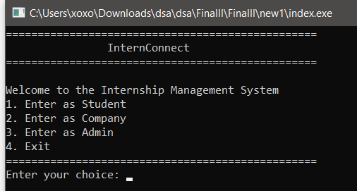

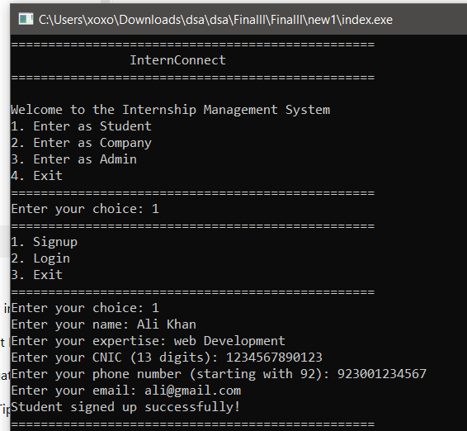
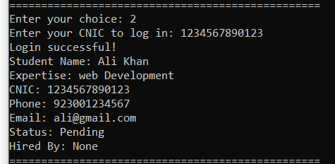

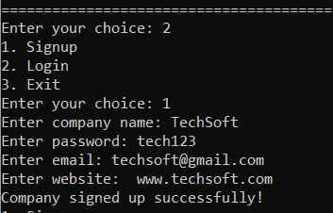\
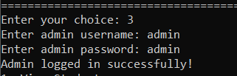

- SANITY TESTING TABLE :
Test ID | Scenario | Input | Expected Result | Actual Result | Status
SAT-01 | Invalid CNIC | 12345 | Error message displayed | Correct error shown | Pass
SAT-02 | Invalid Phone | 03001234567 | Invalid phone error | Error displayed | Pass
SAT-03 | Invalid Email | azia23gmail.com | Invalid email error | Error displayed | Pass
SAT-04 | Duplicate Email | ali@gmail.com | Duplicate email error | Error displayed | Pass
SAT-05 | Wrong Student Login | Wrong CNIC | Login failed | Failed correctly | Pass
SAT-06 | Wrong Admin Login | Wrong password | Admin login failed | Failed correctly | Pass

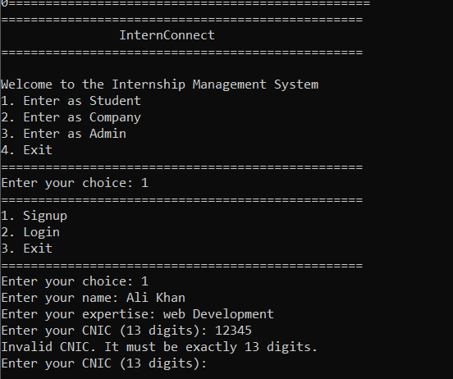

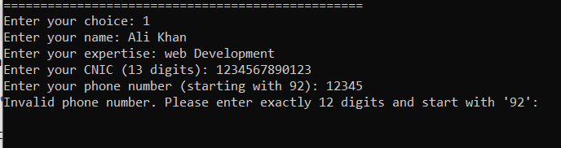

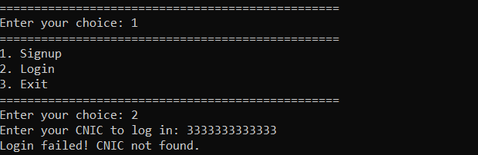
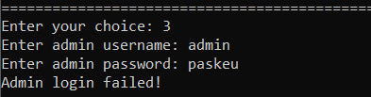

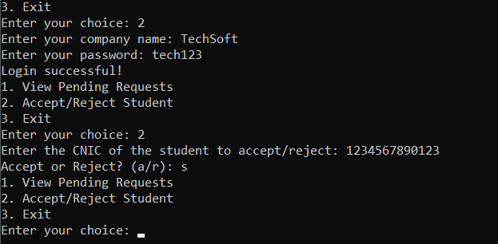

- EXPLORATORY TESTING TABLE:
Test ID | Exploratory Action | Expected Result | Actual Result | Status
ET-01 | Invalid menu option | Error message displayed | Correctly handled | Pass
ET-02 | Letters instead of numbers | Program should not crash | Stable | Pass
ET-03 | Duplicate CNIC signup | Duplicate error shown | Correctly handled | Pass
ET-04 | Login without signup | Login failed message | Correctly displayed | Pass
ET-05 | Invalid accept/reject input | Program should continue running | Stable | Pass

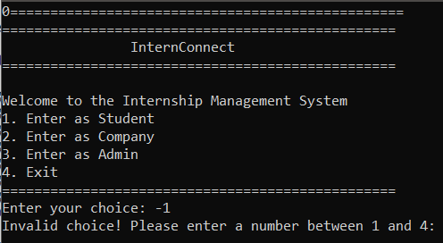

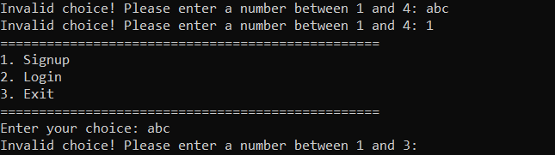

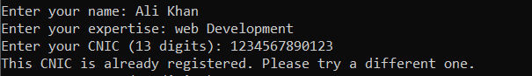

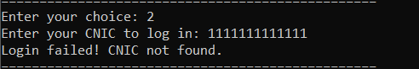



E. Auto Testing:

1. Catch2:

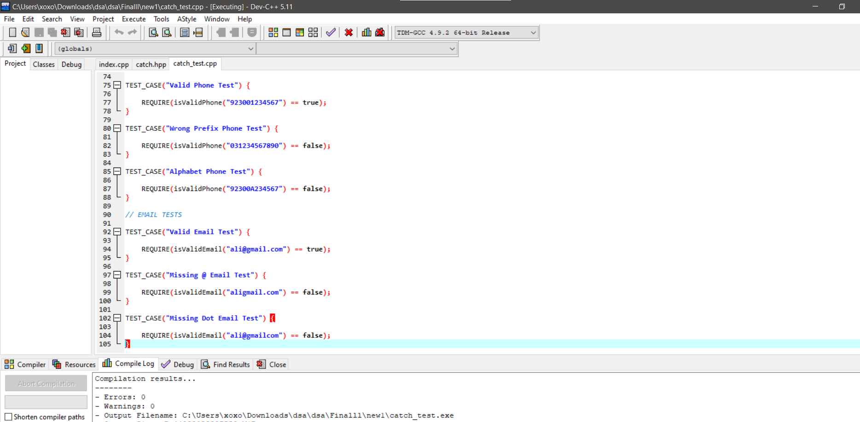

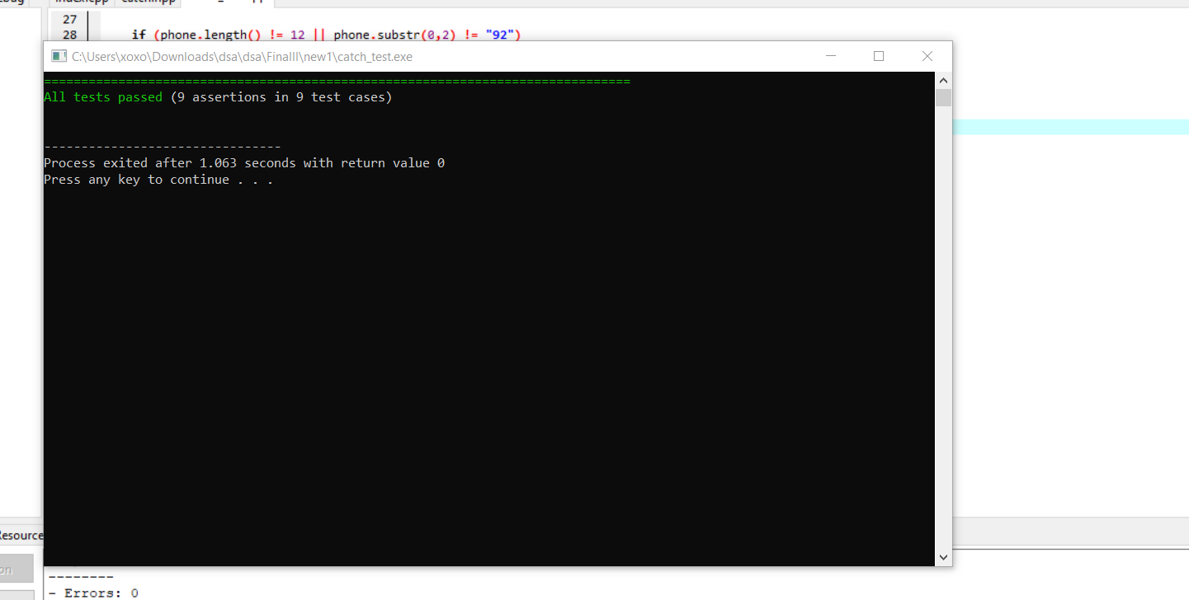

2. Doctest.h:

